**Aetna Member Website – Navigating & Utilizing Aetna Mobile Applications**

Mobile Home Page

Mobile Spending Summary Experience

Mobile ID Cards Experience

Pending Members

**Description:** The purpose of this document is to provide basic information about the Aetna Mobile applications.

**Notes:**

* The examples in this document are specific to iOS iPhone. The Android navigation experience is the same.
* Commercial members can submit Medical claims directly through Aetna Health mobile app using their **iOS (iPhone)** or **Android** device. If the Member asks about submitting a medical claim through the app, refer the member to MSO (Member Services).

|  |
| --- |
| **Mobile Home Page** |

Members can download the mobile app by following these steps:

|  |  |
| --- | --- |
| **Step** | **Action** |
| **1** | Log in to the Aetna Mobile App.  **Result:** |

**Mobile Home Page Navigation At The Top Of The App:**

|  |  |
| --- | --- |
| **Feature Icon** | **Description** |
| Speech bubble icon | At the very top of the Home page, members can send and receive messages from customer service by clicking this icon. |
| Bell icon | Will let a member know if they have any alerts or actions they need to complete for their account. |
| Profile icon | Will allow a member access to their Profile and Preferences page where they can update their profile settings. |
| Quick Care | Member’s will be able to search for quick care providers (like urgent care or emergency rooms). |
| ID Card(s) | A member can access ID card(s). |
| Benefits Section | If the member has additional plans (dental, vision, etc.), they can swipe left on the **Benefits section** to view coverage details.    When the member swipes left, they'll be able to view additional plans, benefits and plan documents, spending details, and service usage (if applicable). |

**Mobile Home Page Navigation At The Bottom Of The App:**

|  |  |
| --- | --- |
| **Feature Icon** | **Description** |
| Home icon | They can click this from anywhere in the app to return to the **Home page**. |
| Claims icon | To view and manage claims. |
| Prescriptions icon | For pharmacy management features. |
| Find Care | To search for a provider, facility, service, or prescription. |
| Service Usage | Members will see in and out-of-network spending, along with messaging explaining what their maximum out-of-pocket amount is before the plan pays 100%. |
| Spending Details | (If available) will help Members keep track of how they've used covered services in their plan year. For further information on Spending Details, refer to Mobile Spending Summary Experience. |
| Account Balances | If the member has a health spending account, they'll see links to view account balances, along with additional links to view balance details in this section. |
| Rewards Center | If the member has Healthy Rewards, they can view their rewards balance and access the Rewards Center to redeem rewards by tapping this panel. |
| Customer Support | Members can tap this option to access the **Support page**, which provides them with guides for understanding how their plan works. |
| Need more details about your plan? | Members can tap here to access the **mobile version** of the **Aetna member website**. |
| You input helps us improve our app. | Members can tap here to **provide feedback**on their **Aetna Health mobile app experience**. |

When the member reaches the bottom of Home page, they'll see navigation shortcuts. These shortcuts provide easy access to additional features in the Aetna Health mobile app.

**Here's an overview of the various feature shortcuts members can tap at the bottom of the Home page:**

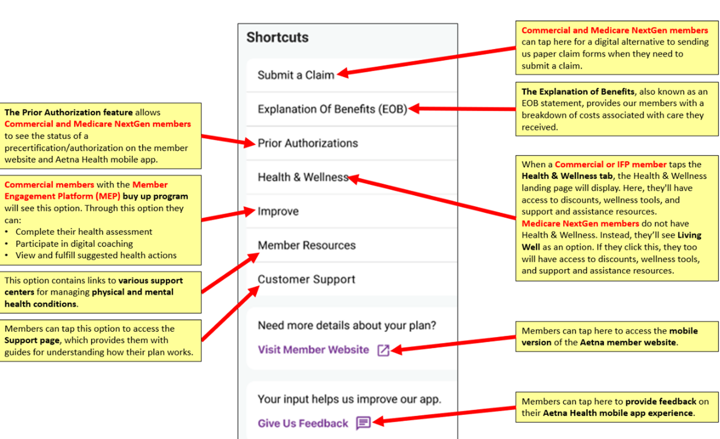

|  |  |
| --- | --- |
| **Feature Link** | **Description** |
| Submit a Claim | **Commercial and Medicare NextGen members** can tap here for a digital alternative to sending us paper claim forms when they need to submit a claim. |
| Explanation of Benefits (EOB) | **The Explanation of Benefits**, also known as an EOB statement, provides our members with a breakdown of costs associated with care they received. |
| Prior Authorizations | **The Prior Authorization feature** allows **Commercial and Medicare NextGen members** to see the status of a precertification/authorization on the Aetna Health mobile app. |
| Health & Wellness (Living Well) | When a**Commercial or IFP member** taps the **Health & Wellness tab**, the **Health & Wellness page**will display. Here, they'll have access to discounts, wellness tools, and support and assistance resources. **Medicare NextGen members** do not have **Health & Wellness**. Instead, they'll see **Living Well**as an option. If they click this, they too will have access to discounts, wellness tools, and support and assistance resources. |
| Improve | **Commercial members**with the **Member Engagement Platform (MEP) buy up program**will see this option. Through this option they can:   * Complete their health assessment * Participate in digital coaching * View and fulfill suggested health actions |
| Member Resources | This option contains links to **various support centers**for managing **physical and mental health conditions**. |
| Customer Support | Members can tap this option to access the **Support page**, which provides them with guides for understanding how their plan works. |
| Need more details about your plan? | Members can tap here to access the **mobile version** of the **Aetna member website**. |
| You input helps us improve our app. | Members can tap here to **provide feedback**on their **Aetna Health mobile app experience**. |

Top of the Document

|  |
| --- |
| **Mobile Spending Summary Experience** |

The spending summary provides users with a clear overview of their healthcare expenses. It allows them to see how much they've spent on healthcare services, including deductibles, copayments, and coinsurance. This financial awareness helps users understand their healthcare costs and make informed decisions about their healthcare spending.

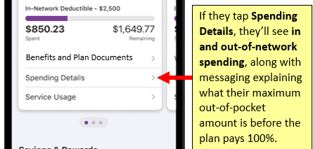

Members will see **In-Network Spending** and can scroll down to see **Out-of-Network** Spending.

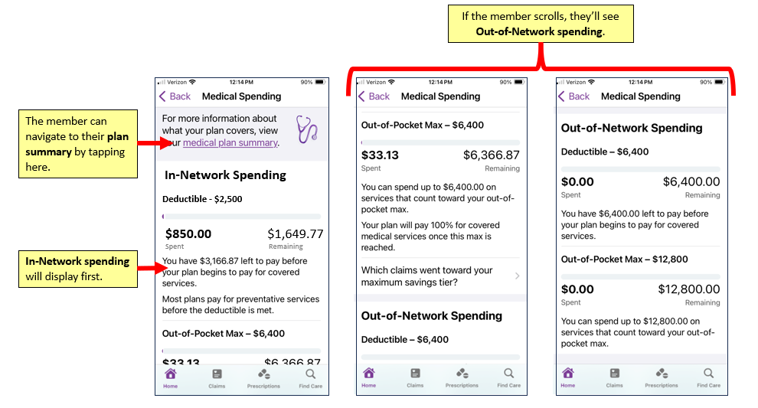

Top of the Document

|  |
| --- |
| **Mobile ID Cards Experience** |

Having access to ID cards on the Aetna Health mobile app eliminates the need to carry physical cards. Members can simply open the app and display their digital ID card when needed.

|  |  |
| --- | --- |
| **Step** | **Action** |
|  | Members can access their ID card from the Home tab by tapping the **ID Cards** button.    **Result:** The ID Card page will display. |
|  | When the **ID Card page** displays, The **selected member's name** will display at the top of the page.   * If there are dependents on the plan, a dependent's name can be selected by tapping the **Selected Member** field. |
|  | To select an ID card for a specific type of plan (**Example:** Medical or Dental), tapthe **Selected ID Card field** and **select the plan type.** |
|  | An image of the ID card will display below the **Selected ID Card** and **Selected Member** fields.    **Note:**   * The member can tap the **Zoom button**to **enlarge the ID card image**. * If they want to see the **back of the ID card**, they'll tap **the ID card image**. * **iOS (iPhone)** users can add their ID card to their Apple Wallet. They can do this by tapping the**Add to Apple Wallet button**. |
|  | If a member would like to **request a physical ID card**, they'll click the **Request a Card button**. |
|  | If a member would like to see additional information about their plan and ID card they'll have the ability to by tapping the **View All Card Information** button.    After they've reviewed his information, they can click the **Back option at the top-left of the page** to return to the **ID Card page**.  **Note:**  In the **ID Card page** a member will see their **member ID number**and **common ID card-specific questions.** |
|  | When they reach to **bottom of the ID Card page**, they can tap the **contact us here link** to view contact information for Customer Service.    They'll also see additional links that'll allow them to **email or print a copy of their ID card**. |

Top of the Document

|  |
| --- |
| **Pending Members** |

​​Members enrolled, but not yet effective on their plans, will have pending plan access on the Aetna Health mobile app for both **Android** and **iOS**.

This means they'll have the ability to perform the following tasks on mobile before their effective date.

They'll be able to:

* Confirm their personal information is correct and update communication preferences.
* View, download and share their pending ID card.
* Search for providers prior to the effective date of the plan to confirm if current providers are in network for the new plan.

|  |  |
| --- | --- |
| **Android Navigation** | **IOS Navigation** |
| The Home page will contain very basic information about their pending plan; as well as the features and functions that are available to them prior to becoming effective. ​    Pending members have the ability to view and update their personal information and communication preferences. This can be done through the Profile & Preferences option, by opening up the main menu. | The **Home** page will contain very basic information about their pending plan and the features and functions that are available to them prior to becoming effective. |
| The **Improve** tab will not be available **until the members’ plan goes into effect.**  If they select this option from the main menu, they'll receive messaging indicating the information isn't available until their effective date. | The **Improve** tab will not be available **until the members’ plan goes into effect**.  If they select this option from the tabs at the bottom, they'll receive messages indicating the information isn't available until their effective date. |
| Pending members will also be able to search for providers prior to the effective date of plan to confirm if current providers are in network for the new plan. However, the actual Search feature on the mobile app will not be available for pending members. They'll need to do this on the mobile web experience, on their mobile browser. When they click the Search feature to look for providers, the app will direct them to mobile web following these steps:   1. Members will click **Search** on the main menu. 2. Their future effective date, along with messaging indicating the types of providers they'll be able to search for when their plan is effective will display. 3. If they want to conduct a search prior to becoming effective, they'll click the **Search for providers** button. 4. This will bring them to the **mobile web experience on their mobile browser**. They'll need to log in and conduct a search using the mobile web experience. | Pending members will also be able to search for providers prior to the effective date of plan to confirm if current providers are in network for the new plan. However, the actual Search feature on the mobile app will not be available for pending members. They'll need to do this on the mobile web experience, on their mobile browser. When they click the Search feature to look for providers, the app will direct them to mobile web following these steps:   1. Members will click Search tab at the bottom of their screen. 2. Their future effective date, along with messaging indicating the types of providers they'll be able to search for when their plan is effective will display. 3. If they want to conduct a search prior to becoming effective, they'll click the Search for providers button. 4. This will bring them to the mobile web experience on their mobile browser. They'll need to log in and conduct a search using the mobile web experience. ​ |
| The **Records** tab will not be available **until the members’ plan goes into effect.**  If they select this option from the main menu, they'll receive messaging indicating the information isn't available until their effective date. | The **Records** tab will not be available **until the members’ plan goes into effect.**  If they select this option from the main menu, they'll receive messaging indicating the information isn't available until their effective date. |

Top of the Document

Not To Be Reproduced Or Disclosed to Others Without Prior Written Approval

**ELECTRONIC DATA = OFFICIAL VERSION / PAPER COPY = INFORMATIONAL ONLY**